**FEASIBILITY ANALYSIS**

**NAME:** Bandi.Dinesh Kumar

**ENROLLMENT NUMBER:** U101114FEC209

**Description about the application:**

Ours is a communication sharing application. The purpose of the application is to make community between students. We have conducted a survey in NIIT University, in which we have got good reviews from most of the students. In which we got 115 students have participated in our survey. I hereby attach you the pie chart from our feasibility document which is generated to everyone.

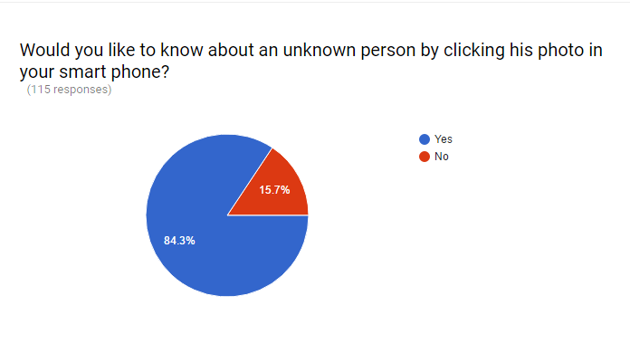

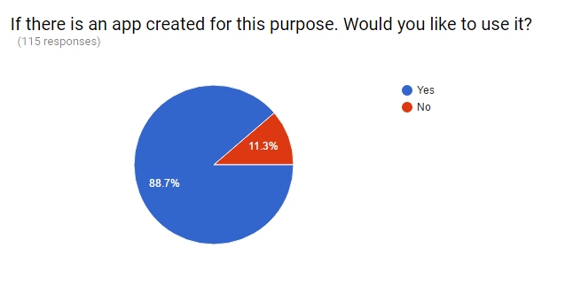

We got 88.7% of positive reviews for using our application after release. And the rest of the people are just afraid of leakage of private information which we will take care in our security measures.

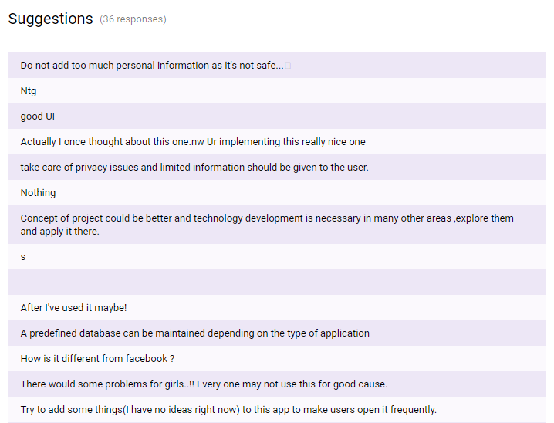

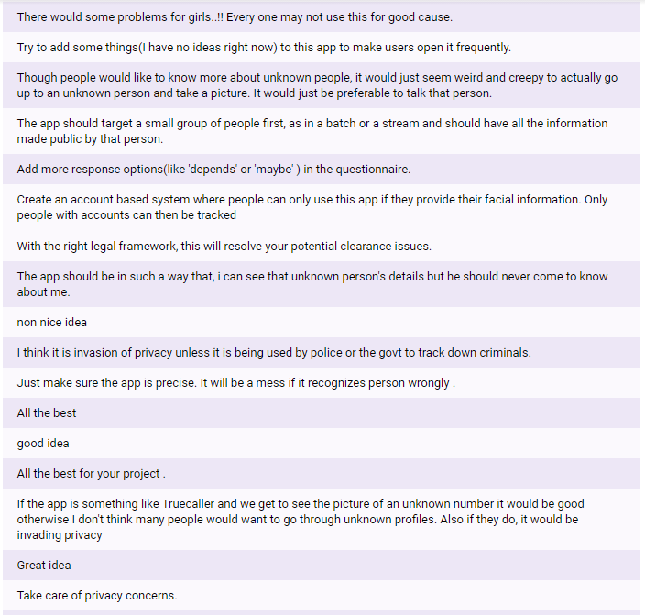

**Recommendation:**

From above all reviews it shows that the application is feasible. And also recommendable.